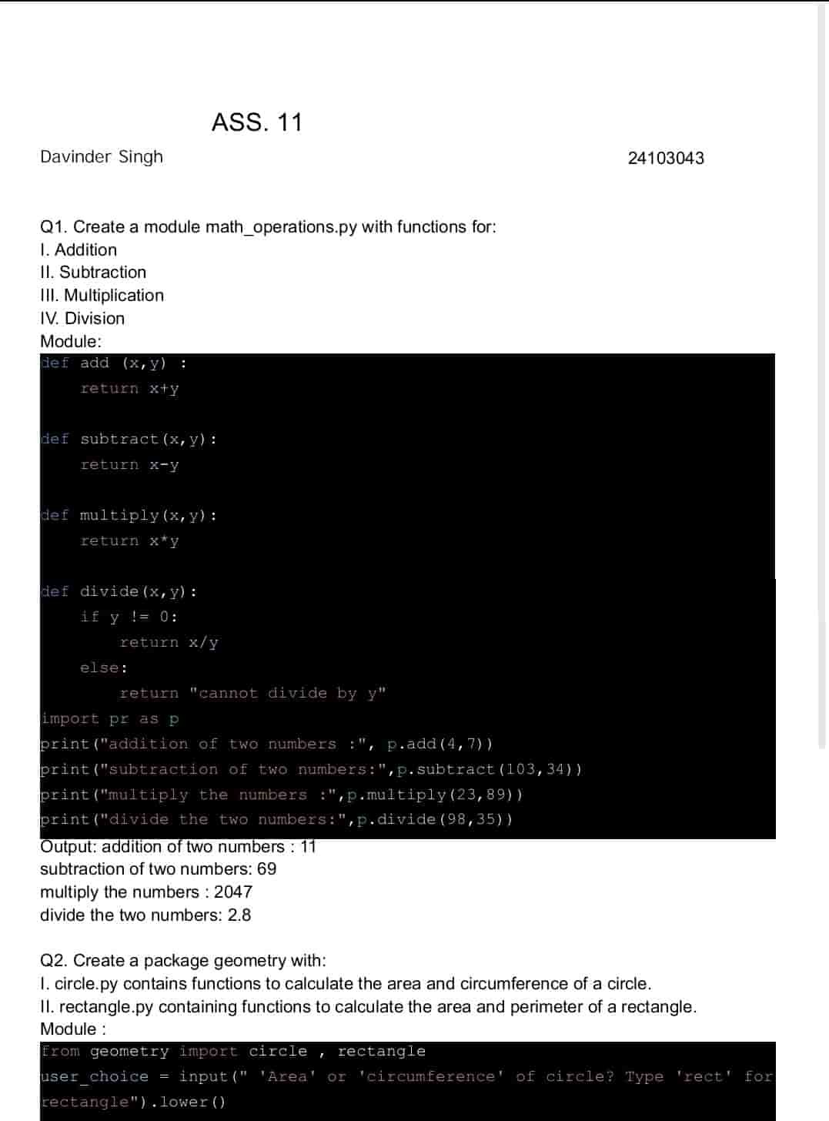

ASSIGNMENT 10

24054

GURVEER SIH

Gurveer Singh

fghftttttttttfffffrxgk

